Reception
Theme/Term | Strength of mind Summer 1 |  |  |  | Family & friends Summer 2
Writing Root Text | 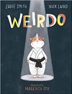  Weirdo  Zadie Smith and Nick Laird |  |  | 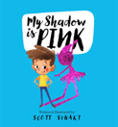  My Shadow is Pink  Scott Stuart | 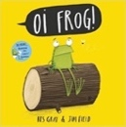  Oi! Frog  Kes Gray and Jim Field | 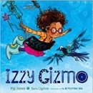  Izzy Gizmo  Pip Jones
Year 1 | Journeys & exploration Autumn 1 |  |  |  | Heroes & villains Autumn 2
Writing Root/  Spelling Seed Text | 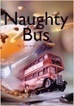  Naughty Bus  Jan Oke and Jerry Oke | 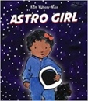  Astro Girl  Ken Wilson-Max |  |  | 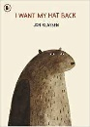  I Want My Hat Back  Jon Klassen | 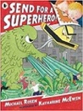  Send for a Superhero  Michael Rosen & Katharine McEwan
Theme/Term | Similarities & differences Spring 1 |  |  |  | Nature & environment Spring 2
Writing Root/  Spelling Seed Text | 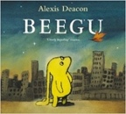  Beegu  Alexis Deacon |  |  | 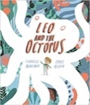  Leo and the Octopus  Isabelle Marinov | 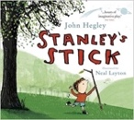  Stanley’s Stick  John Hegley and Neal Layton | 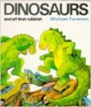  Dinosaurs and all that Rubbish  Michael Foreman
Theme/Term | Friendship & kindness Summer 1 |  |  |  | Imagination & creativity Summer 2
Writing Root/  Spelling Seed Text | 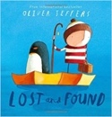  Lost and Found  Oliver Jeffers |  | 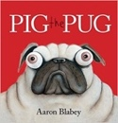  Pig the Pug  Aaron Blabey |  | 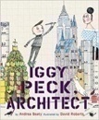  Iggy Peck, Architect  Andrea Beaty and David Roberts | 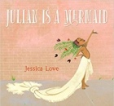  Julian is a Mermaid  Jessica Love
Literary Leaf Text  (Off RWI) | 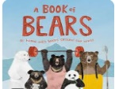  A book of Bears  ] Katie Viggers  Katie Viggers  Katie Viggers |  | 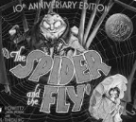  The Spider and the Fly  Mary Howitt and Tony DiTerlizzi |  | 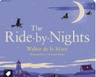  Ride-by-Nights  Walter de la Mare | 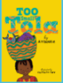  Too small Tola  Atinuke
Year 2 | A twist in the tale Autumn 1 |  |  |  | Creation & conservation Autumn 2
Writing Root/  Spelling Seed Text | 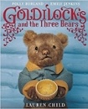  Goldilocks & the Three Bears  Lauren Child |  | 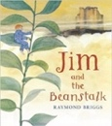  Jim and the Beanstalk  Raymond Briggs |  | 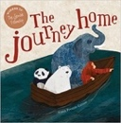  The Journey Home  Frann Preston-Gannon | 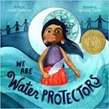  We Are Water Protectors  Carole Lindstrom
Literary Leaf Text | 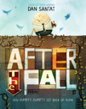  After the Fall  Dan Santat | 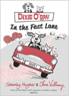  Dixie O’Day: In the Fast Lane  Claire Valliumy |  |  | 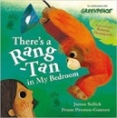  There’s a Rang-Tan in my Bedroom  James Sellick | 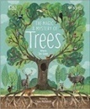  The Magic and Mystery of Trees  Jen Green
Theme/Term | Bravery vs. fear Spring 1 |  |  |  | Change & relationships Spring 2
Writing Root/  Spelling Seed Text | 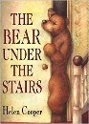  The Bear Under the Stairs  Helen Cooper |  | 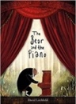  The Bear and the Piano  David Litchfield |  | 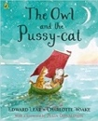  The Owl and the Pussy-cat  Edward Lear |   If All the World Were…  Joseph Coelho
Literary Leaf Text | 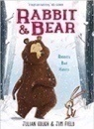  Rabbit and Bear by Julian Gough & Jim Field |  | 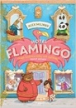  Hotel Flamingo  Alex Milway |  | 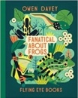  Fanatical about Frogs  Owen Davey
Theme/Term | Fictional Worlds & fantasy Summer 1 |  |  |  | Urban metropolis Summer 2
Writing Root/  Spelling Seed Text | 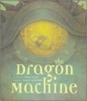  The Dragon Machine  Helen Ward |  | 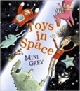  Toys in Space  Mini Grey |  | 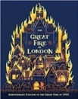  The Great Fire of London  Emma Adams | 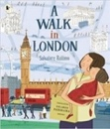  A Walk in London  Salvatore Rubbino
Literary Leaf Text | 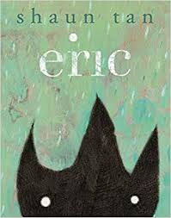  Eric  Shaun Tan |  | 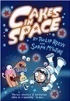  Cakes in Space  Philip Reeve |  | 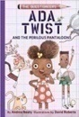  Ada Twist and the Perilous Pantaloons  Andrea Beaty | 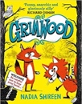  Grimwood  Nadia Shireen
Year 3 | Magic & wonder Autumn 1 |  |  |  | Dreams & curiosity Autumn 2
Writing Root/  Spelling Seed Text | 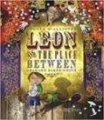  Leon and the Place Between  Angela McAllister |  | 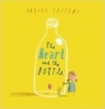  The Heart and the Bottle  Oliver Jeffers |  | 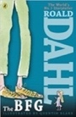  The BFG  Roald Dahl | 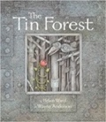  The Tin Forest  Helen Ward
Literary Leaf Text | 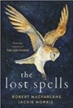  The Lost Spells  Robert MacFarlane |  |  |  | 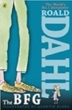  The BFG  Roald Dahl
Theme/Term | Disaster, hope & healing Spring 1 |  |  |  | Overcoming adversity Spring 2
Writing Root/  Spelling Seed Text | 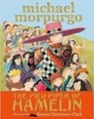  The Pied Piper of Hamelin  Michael Morpurgo |  | 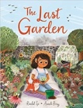  The Last Garden  Rachel Ip |  | 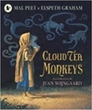  Cloud Tea Monkeys  Mal Peet & Elspeth Graham | 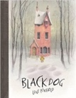  Black Dog  Levi Pinfold
Literary Leaf Text | 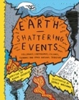  Earth Shattering Events  Robin Jacobs |  |  |  | 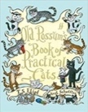  Old Possum’s Book of Practical Cats  T. S. Eliot
Theme/Term | From mystery to discovery Summer 1 |  |  |  | Confidence & caution Summer 2
Writing Root/  Spelling Seed Text | 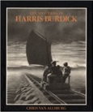  The Mysteries of Harris Burdick  Chris Van Allsberg |  | 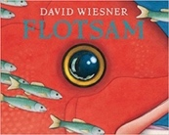  Flotsam  David Wiesner |  | 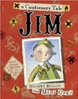  Jim, A Cautionary Tale  Hilaire Belloc | 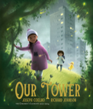  Our Tower  Joseph Coelho
Literary Leaf Text | 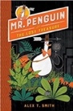  Mr Penguin and the Lost Treasure  Alex T. Smith |  |  |  | 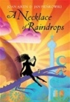  A Necklace of Raindrops  Joan Aiken
Year 4 | Finding Freedom Autumn 1 |  |  |  | Invention & innovation Autumn 2
Writing Root/  Spelling Seed Text | 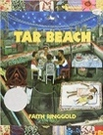  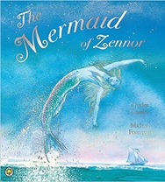  Tar Beach  Faith Ringgold |  | 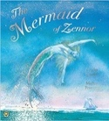  The Mermaid of Zennor  Charles Causley |  | 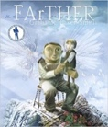  FArTHER  Grahame Baker Smith | 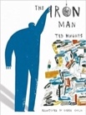  The Iron Man  Ted Hughes
Literary Leaf Text | 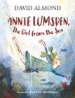  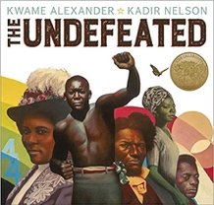  Annie Lumsden, The Girl from the Sea  David Almond |  |  |  | 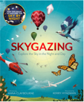  Skygazing  Anna Claybourne and Kerry Hyndman
Theme/Term | Darkness & light Spring 1 |  |  |  | Taking courage Spring 2
Writing Root/  Spelling Seed Text | 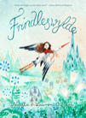  Frindleswylde  Natalia O’Hara & Lauren O’Hara | 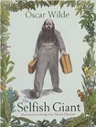  The Selfish Giant  Oscar Wilde |  |  | 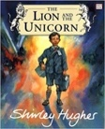  The Lion and the Unicorn  Shirley Hughes | 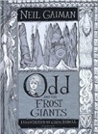  Odd and the Frost Giants  Neil Gaiman
Literary Leaf Text | 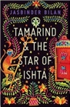  Tamarind and the Star of Ishta  Jasbinder Bilan |  |  |  | 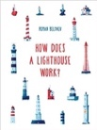  How Does a Lighthouse Work?  Roman Belyaev
Theme/Term | Unearthing Civilisations Summer 1 |  |  |  | Different worlds Summer 2
Writing Root/  Spelling Seed Text | 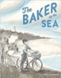  The Baker by the sea by Paula White | Shackleton’s Journey  William Grill  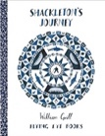 |  |  | 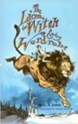  The Lion the Witch and the Wardrobe  C. S. Lewis | 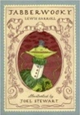  Jabberwocky  Lewis Carroll
Literary Leaf Text | 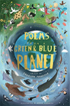  Poems from a Green and Blue Planet  Sabrina Mahfouz |  |  |  | The Lion the Witch and the Wardrobe  C. S. Lewis

Year 5 | Ambition & desire Autumn 1 |  |  |  | Power vs. principles Autumn 2
Writing Root /  Spelling Seed Text | 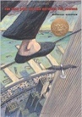  The Man Who Walked Between the Towers  Mordicai Gerstein | 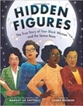  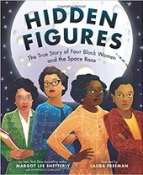  Hidden Figures  Margot Lee Shetterly |  |  | 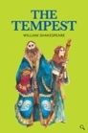  The Tempest  William Shakespeare | 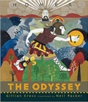  The Odyssey  Gillian Cross
Literary Leaf Text | 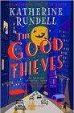  The Good Thieves  Katherine Rundell |  |  |  | 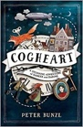  Cogheart  Peter Bunzl
Theme/Term | Belonging & equality Spring 1 |  |  |  | Legends & folklore Spring 2
Writing Root /  Spelling Seed Text | 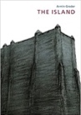  The Island  Armin Greder |  | 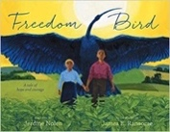  Freedom Bird  Jerdine Nolen |  | 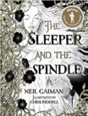  The Sleeper and the Spindle  Neil Gaiman and Chris Riddell | 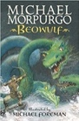  Beowulf  Michael Morpurgo
Literary Leaf Text | 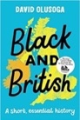  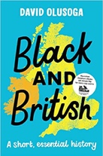  Black and British: A short, essential history  David Olusoga |  |  |  | 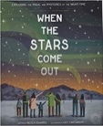  When the Stars Come Out  Nicola Edwards
Theme/Term | Lessons from history Summer 1 |  |  |  | Mystery & truth Summer 2
Writing Root /  Spelling Seed Text | 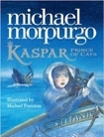  Kaspar, Prince of Cats  Michael Morpurgo |  |  | 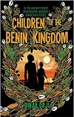  Children of the Benin Kingdom  Dina Orji | 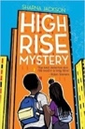  High Rise Mystery  Sharna Jackson | 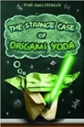  Origami Yoda  Tom Angleberger
Literary Leaf Text | 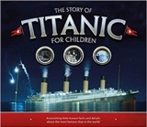  The Story of Titanic for Children Joe Fullman  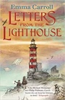  Letters from the Lighthouse |  |  |  | 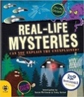  Real-life Mysteries  Susan Martineau and Vicky Barker
Year 6 | Migration & movement Autumn 1 |  |  |  | Evolution & inheritance Autumn 2
Writing Root /  Spelling Seed Text | 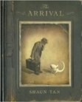  The Arrival  Shaun Tan |  |  | 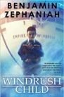  Windrush Child  Benjamin Zephaniah | 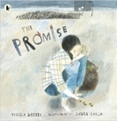  The Promise  Nicola Davies | 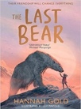  The Last Bear  Hannah Gold
Literary Leaf Text | 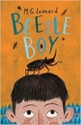  Beetle Boy  M. G. Leonard |  |  |  | 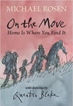  On the Move: Poems about Migration  Michael Rosen
Theme/Term | Enterprise & activism Spring 1 |  |  |  | Utopia vs. dystopia Spring 2
Writing Root /  Spelling Seed Text | 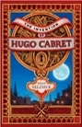  The Invention of Hugo Cabret  Brian Selznick | 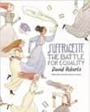  Suffragette: The Battle for Equality  David Roberts |  |  | 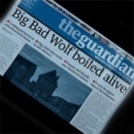  The Three Little Pigs Project  The Guardian | 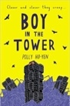  Boy in the Tower  Polly Ho-Yen
Literary Leaf Text | The Invention of Hugo Cabret  Brian Selznick |  |  |  | 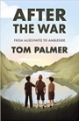  After the War: From Auschwitz to Ambleside  Tom Palmer
Theme/Term | Fate vs. free will Summer 1 |  |  |  | Crossing borders Summer 2
Writing Root /  Spelling Seed Text | 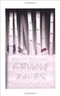  Grimm Tales for Young and Old Phillip Pullman | 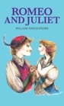  Romeo and Juliet  William Shakespeare |  |  | 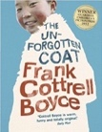  The Unforgotten Coat  Frank Cottrell Boyce | 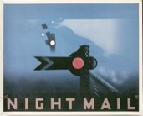  Night Mail  W H Auden
Literary Leaf Text | Grimm Tales for Young and Old  Phillip Pullman |  |  |  | 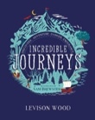  Incredible Journeys  Levison Wood

