Reception
Theme/Term | Autumn 1 |  |  |  | Autumn 2
Reading and Phonics | Group A  Begin to learn sounds |  |  |  | Group B  Recognise 15 sounds
Books we would like children to hear | Nursery Rhymes  You be you Linda Kranz  Shine Sarah Asuouo  The Go away bird - Julia Donaldson  Titch Pat Hutchins  Funny Bones Allan Ahlberg |  |  |  | Brown Bear, Brown Bear Bill Martin  Gruffalo Julia Donaldson  Because Mo Willems  All join in Quentin Blake  A range of traditional nursery rhymes
Theme/Term | Spring 1 |  |  |  | Spring 2
Reading and Phonics | Group C  Recognise 24 sounds |  |  |  | Read ditty sheets  Recognise 30 sounds
Books we would like children to hear | The tiger who came for tea Judith Kerr  Oi Frog Collection  The Ugly Five Julia Donaldson  Is there a dog in this book Viviane Schwarz  Spinderalla – Julia Donaldson  Hairy Maclary Linley Dodd |  |  |  | The Tiny Seed Eric Carle  Avocado Baby John Burningham  Oliver’s Vegetables Vivian French  The Gigantic Turnip Aleksei Tolstoy  Supertato Sue Hendra
Theme/Term | Strength of mind Summer 1 |  |  |  | Family & friends Summer 2
Writing Root Text | 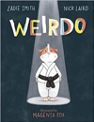  Weirdo  Zadie Smith and Nick Laird |  |  | 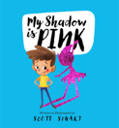  My Shadow is Pink  Scott Stuart | 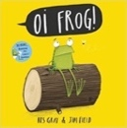  Oi! Frog  Kes Gray and Jim Field | 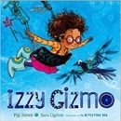  Izzy Gizmo  Pip Jones
Reading and Phonics | Read red story books  Recognise 34 sounds |  |  |  | Read green story books  Recognise 40 sounds
Books we would like children to hear | The hundred decker bus Mike Smith |  |  |  | The Rainbpw Fish Marcus Pfister  The Snail and the Whale Julia Donaldson  Tiddler Julia Donaldson
Year 1 | Journeys & exploration Autumn 1 |  |  |  | Heroes & villains Autumn 2
Writing Root/  Spelling Seed Text | 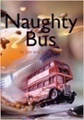  Naughty Bus  Jan Oke and Jerry Oke | 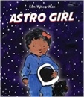  Astro Girl  Ken Wilson-Max |  |  | 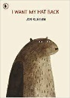  I Want My Hat Back  Jon Klassen | 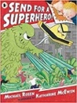  Send for a Superhero  Michael Rosen & Katharine McEwan
Reading and Phonics | Read green story books  Recognise 46 sounds |  |  |  | Read purple story books  Recognise 51 sounds
Books we would like children to hear | Grandad’s Island Benji Davies  Here we are Oliver Jeffers  Journey Aaron Becker  Cave Baby Julia Donaldson |  |  |  | Little Red Bethan Woollvin  Rapunzel Bethan Woollvin  Billy Goats Gruff Alison Edgeson  The Baddies Julia Donaldson
Theme/Term | Similarities & differences Spring 1 |  |  |  | Nature & environment Spring 2
Writing Root/  Spelling Seed Text | 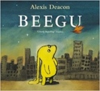  Beegu  Alexis Deacon |  |  | 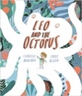  Leo and the Octopus  Isabelle Marinov | 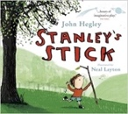  Stanley’s Stick  John Hegley and Neal Layton | 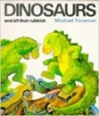  Dinosaurs and all that Rubbish  Michael Foreman
Reading and Phonics | Read pink story books  Recognise 57 sounds |  |  |  | Read orange story books  Recognise 63 sounds
Literacy Tree  (Off the programme) |  |  |  |  |   A book of Bears  Katie Viggers
Books we would like children to hear | The Smartest Giant in Town Julia Donaldson  Freddy & the Fairy Julia Donaldson  Monkey Puzzle Julia Donaldson  Room on the Broom Julia Donaldson  Knuffle Bunny Mo Willems  Elmer David McKee |  |  |  | Bog baby  Lots – The diversity of Life on Earth  Where the Wild things are Maurice Sandak  Owl Babies Martain Waddell  Leaf Man Lois Ehlt
Theme/Term | Friendship & kindness Summer 1 |  |  |  | Imagination & creativity Summer 2
Writing Root/  Spelling Seed Text | 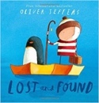  Lost and Found  Oliver Jeffers |  | 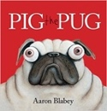  Pig the Pug  Aaron Blabey |  | 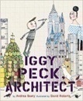  Iggy Peck, Architect  Andrea Beaty and David Roberts | 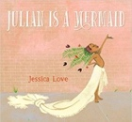  Julian is a Mermaid  Jessica Love
Literary Leaf Text  (Off the programme) | 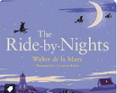  Ride-by-Nights  Walter de la Mare |  | 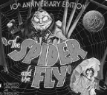  The Spider and the Fly  Mary Howitt and Tony DiTerlizzi |  | 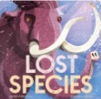  The Lost Species  Jess French | 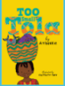  Too small Tola  Atinuke
Reading and Phonics | Read yellow story books  Recognise 68 sounds |  |  |  | Read yellow story books  Recognise 75 sounds
Books we would like children to hear | The Way Back Home Oliver Jeffers  On Sudden Hill Linda Sarah  Farmer Duck Martin Waddell |  |  |  | Dogger Shirley Hughes  Grandpa John Burningham  The Lost Toys in the Museum David Lucas  The rabbit that belongs to Emily Brown Cressida Cowell
Year 2 | A twist in the tale Autumn 1 |  |  |  | Creation & conservation Autumn 2
Writing Root/  Spelling Seed Text | 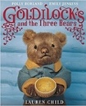  Goldilocks & the Three Bears  Lauren Child |  | 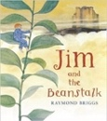  Jim and the Beanstalk  Raymond Briggs |  | 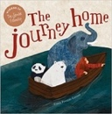  The Journey Home  Frann Preston-Gannon | 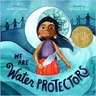  We Are Water Protectors  Carole Lindstrom
Literary Leaf Text | 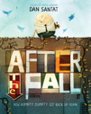  After the Fall  Dan Santat | 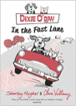  Dixie O’Day: In the Fast Lane  Claire Valliumy |  |  | 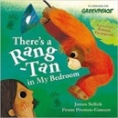  There’s a Rang-Tan in my Bedroom  James Sellick | 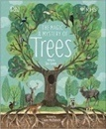  The Magic and Mystery of Trees  Jen Green
RWI Expectation | Read blue story books |  |  |  | Read blue story books
Books we would like children to hear | You Choose Fairy Tales Pippa Goodhart  Snow White in New York Fiona French  The true story of 3 pigs Jon Scieszka  Each Peach Pear Plum Allan Ahlberg  The Jolly Postman Allan Ahlberg  Egyptian Cinderella Shirley Climo |  |  |  | Katie in London James Mayhew  Katie in Scotland James Mayhew  The King’s Knickers Nicholas Allan  The Queen’s Hat Stacey Anthony  The Secret Sky Garden Linda Sarah  The golden Wonderflower Benjamin Flouw  Footpath Flowers Jon Arno Lawson
Theme/Term | Bravery vs. fear Spring 1 |  |  |  | Change & relationships Spring 2
Writing Root/  Spelling Seed Text | 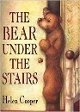  The Bear Under the Stairs  Helen Cooper |  | 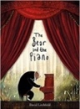  The Bear and the Piano  David Litchfield |  | 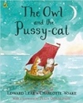  The Owl and the Pussy-cat  Edward Lear | 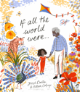  If All the World Were…  Joseph Coelho
Literary Leaf Text | 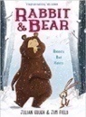  Rabbit and Bear by Julian Gough & Jim Field |  | 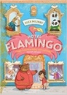  Hotel Flamingo  Alex Milway |  | 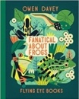  Fanatical about Frogs  Owen Davey
RWI Expectation | Read grey story books |  |  |  | Read grey story books
Books we would like children to hear | The Magic Finger Roald Dahl  George’s Marvellous Medicine Roald Dahl  Oliver Hilary McKay  Grandad’s Camper Harry Woodgate  Wild Emily Hughes
Theme/Term | Fictional Worlds & fantasy Summer 1 |  |  |  | Urban metropolis Summer 2
Writing Root/  Spelling Seed Text | 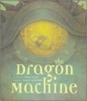  The Dragon Machine  Helen Ward |  | 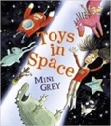  Toys in Space  Mini Grey |  | 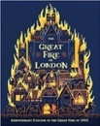  The Great Fire of London  Emma Adams | 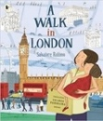  A Walk in London  Salvatore Rubbino
Literary Leaf Text | 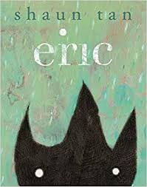  Eric  Shaun Tan |  | 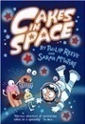  Cakes in Space  Philip Reeve |  | 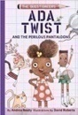  Ada Twist and the Perilous Pantaloons  Andrea Beaty | 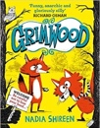  Grimwood  Nadia Shireen
Books we would like children to hear | How to catch a star Oliver Jeffers  Man on the Moon Simon Bartum  Goodnight Spaceman Michelle Robison  The Darkest day Chris Hadfield  Last Stop on Market Street Matt de la Peña  Ros Montgomery - The building Boy  The street beneath my feet Charlotte Guillian
Year 3 | Magic & wonder Autumn 1 |  |  |  | Dreams & curiosity Autumn 2
Writing Root/  Spelling Seed Text | 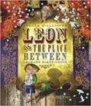  Leon and the Place Between  Angela McAllister |  | 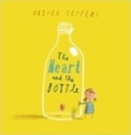  The Heart and the Bottle  Oliver Jeffers |  | 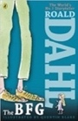  The BFG  Roald Dahl | 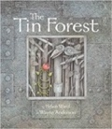  The Tin Forest  Helen Ward
Literary Leaf Text | 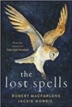  The Lost Spells  Robert MacFarlane |  |  |  | 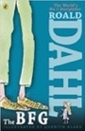  The BFG  Roald Dahl
Books we would like children to hear | Arthur and the Golden Rope Joe Todd Stanton  Madeleine Ludwig Bemelmans  Coming to England Floella Benjamin  A Walk in Paris Salvatore Rubbino  Jumanji Chris Van Alsburg  New and Collected Poems for Children Carol Ann Duffy
Theme/Term | Disaster, hope & healing Spring 1 |  |  |  | Overcoming adversity Spring 2
Writing Root/  Spelling Seed Text | 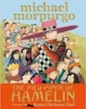  The Pied Piper of Hamelin  Michael Morpurgo |  | 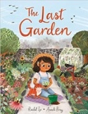  The Last Garden  Rachel Ip |  | 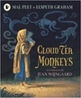  Cloud Tea Monkeys  Mal Peet & Elspeth Graham | 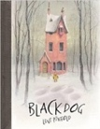  Black Dog  Levi Pinfold
Literary Leaf Text | 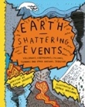  Earth Shattering Events  Robin Jacobs |  |  |  | 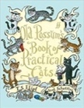  Old Possum’s Book of Practical Cats  T. S. Eliot
Books we would like children to hear | The Pied Piper of Hamelin Robert Browning  Ug Raymond Briggs  How to wash a wool mammoth Michelle Robinson  There’s a pebble in my pocket Meredith Hooper  Stone Age Boy Satoshi Kitamura  Stone Girl, Bone Girl Laurence Anholt  We’re all wonders RJ Palacio  The Dot Peter H Reynolds  Ava Twist Scientist Andrea Beatty  The White Fox Jackie Morris
Theme/Term | From mystery to discovery Summer 1 |  |  |  | Confidence & caution Summer 2
Writing Root/  Spelling Seed Text | 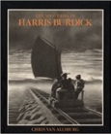  The Mysteries of Harris Burdick  Chris Van Allsberg |  | 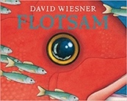  Flotsam  David Wiesner |  | 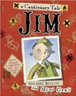  Jim, A Cautionary Tale  Hilaire Belloc | 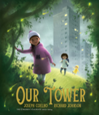  Our Tower  Joseph Coelho
Literary Leaf Text | 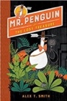  Mr Penguin and the Lost Treasure  Alex T. Smith |  |  |  | 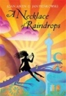  A Necklace of Raindrops  Joan Aiken
Books we would like children to hear | A house that once was Julie Fogliano  The Secret of Black Rock Joe Todd Stanton  Flat Stanley – The great Egyptian grave robbery.  I am the Seed that Grew the Tree - Fiona Waters  Fortunately, the Milk Neil Gaiman
Year 4 | Finding Freedom Autumn 1 |  |  |  | Invention & innovation Autumn 2
Writing Root/  Spelling Seed Text | 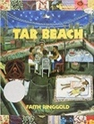  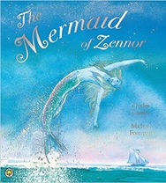  Tar Beach  Faith Ringgold |  | 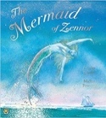  The Mermaid of Zennor  Charles Causley |  | 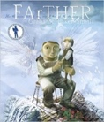  FArTHER  Grahame Baker Smith | 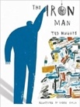  The Iron Man  Ted Hughes
Literary Leaf Text | 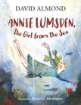  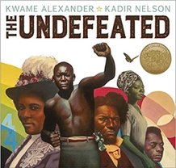  Annie Lumsden, The Girl from the Sea  David Almond |  |  |  | 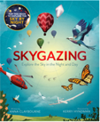  Skygazing  Anna Claybourne and Kerry Hyndman
Books we would like children to hear | Rhythm of the Rain Graham Baker-Smith  Once upon a Raindrop James Carter  The Great Kapok Tree Lynne Cherry  Rosie Revere Engineer Andrea Beatty  Up and down Oliver Jeffers  The Undefeated Kwame Alexander  The Story of Flight Jakob Whitfield
Theme/Term | Darkness & light Spring 1 |  |  |  | Taking courage Spring 2
Writing Root/  Spelling Seed Text | 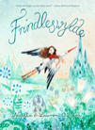  Frindleswylde  Natalia O’Hara & Lauren O’Hara | 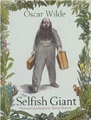  The Selfish Giant  Oscar Wilde |  |  | 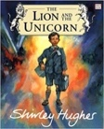  The Lion and the Unicorn  Shirley Hughes | 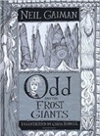  Odd and the Frost Giants  Neil Gaiman
Literary Leaf Text | 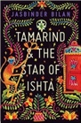  Tamarind and the Star of Ishta  Jasbinder Bilan |  |  |  | 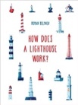  How Does a Lighthouse Work?  Roman Belyaev
Books we would like children to hear | Winter’s Child Angela McAllister  Norse Myths
Theme/Term | Unearthing Civilisations Summer 1 |  |  |  | Different worlds Summer 2
Writing Root/  Spelling Seed Text | 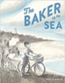  The Baker by the sea by Paula White | Shackleton’s Journey  William Grill  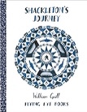 |  |  | 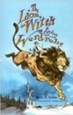  The Lion the Witch and the Wardrobe  C. S. Lewis | 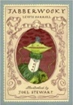  Jabberwocky  Lewis Carroll
Literary Leaf Text | 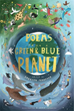  Poems from a Green and Blue Planet  Sabrina Mahfouz |  |  |  | The Lion the Witch and the Wardrobe  C. S. Lewis
Books we would like children to hear | The Last Firefox Lee Newbery  Two Weeks with the Queen Morris Geitzman

Year 5 | Ambition & desire Autumn 1 |  |  |  | Power vs. principles Autumn 2
Writing Root /  Spelling Seed Text | 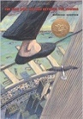  The Man Who Walked Between the Towers  Mordicai Gerstein | 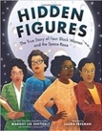  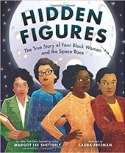  Hidden Figures  Margot Lee Shetterly |  |  | 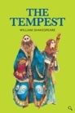  The Tempest  William Shakespeare | 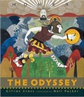  The Odyssey  Gillian Cross
Literary Leaf Text | 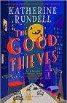  The Good Thieves  Katherine Rundell |  |  |  | 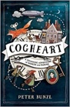  Cogheart  Peter Bunzl
Books we would like children to hear | Pattan’s Pumpkin Chitra Soundar  Flood Alvaro Villa  The day the war came Nicola Davies  Little People, Big Dreams  Harriet Tubman  The Bluest of Blues Fiona Robinson
Theme/Term | Belonging & equality Spring 1 |  |  |  | Legends & folklore Spring 2
Writing Root /  Spelling Seed Text | 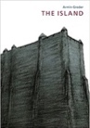  The Island  Armin Greder |  | 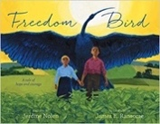  Freedom Bird  Jerdine Nolen |  | 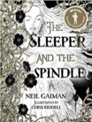  The Sleeper and the Spindle  Neil Gaiman and Chris Riddell | 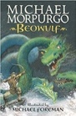  Beowulf  Michael Morpurgo
Literary Leaf Text | 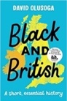  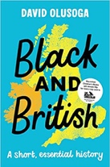  Black and British: A short, essential history  David Olusoga |  |  |  | 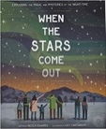  When the Stars Come Out  Nicola Edwards
Books we would like children to hear | There’s a Viking in my bed Jeremy Strong  Jouney Francesca Sanna  Azzi in Bewteen Sarah Garland  The Wonderling Mira Bartok
Theme/Term | Lessons from history Summer 1 |  |  |  | Mystery & truth Summer 2
Writing Root /  Spelling Seed Text | 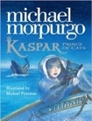  Kaspar, Prince of Cats  Michael Morpurgo |  |  | 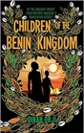  Children of the Benin Kingdom  Dina Orji | 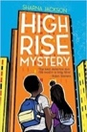  High Rise Mystery  Sharna Jackson | 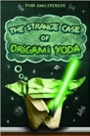  Origami Yoda  Tom Angleberger
Literary Leaf Text | 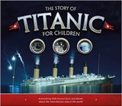  The Story of Titanic for Children Joe Fullman  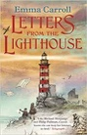 |  |  |  | 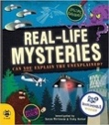  Real-life Mysteries  Susan Martineau and Vicky Barker
Books we would like children to hear | When Hitler Stole Pink Rabbit Judith Kerr
Year 6 | Migration & movement Autumn 1 |  |  |  | Evolution & inheritance Autumn 2
Writing Root /  Spelling Seed Text | 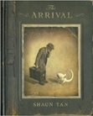  The Arrival  Shaun Tan |  |  | 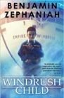  Windrush Child  Benjamin Zephaniah | 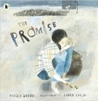  The Promise  Nicola Davies | 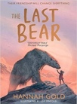  The Last Bear  Hannah Gold
Literary Leaf Text | 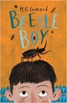  Beetle Boy  M. G. Leonard |  |  |  | 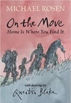  On the Move: Poems about Migration  Michael Rosen
Books we would like children to hear | Queen of the Falls Van Allsburg  The Crows Tale Naomi Howarth  One Boy’s War Lynn Huggins – Cooper  Silence Seekers Ben Morley |  |  |  | Moth (evolution) Isabel Thomas  Origin of the Species Charles Darwin
Theme/Term | Enterprise & activism Spring 1 |  |  |  | Utopia vs. dystopia Spring 2
Writing Root /  Spelling Seed Text | 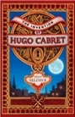  The Invention of Hugo Cabret  Brian Selznick | 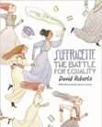  Suffragette: The Battle for Equality  David Roberts |  |  | 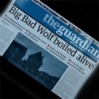  The Three Little Pigs Project  The Guardian | 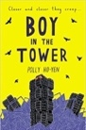  Boy in the Tower  Polly Ho-Yen
Literary Leaf Text | The Invention of Hugo Cabret  Brian Selznick |  |  |  | 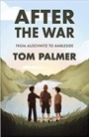  After the War: From Auschwitz to Ambleside  Tom Palmer
Books we would like children to hear | Letters from the Lighthouse  Emma Carroll
Theme/Term | Fate vs. free will Summer 1 |  |  |  | Crossing borders Summer 2
Writing Root /  Spelling Seed Text | 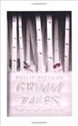  Grimm Tales for Young and Old Phillip Pullman | 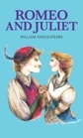  Romeo and Juliet  William Shakespeare |  |  | 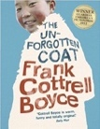  The Unforgotten Coat  Frank Cottrell Boyce | 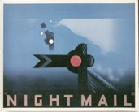  Night Mail  W H Auden
Literary Leaf Text | Grimm Tales for Young and Old  Phillip Pullman |  |  |  | 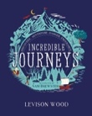  Incredible Journeys  Levison Wood
Books we would like children to hear | Poetry for Kids: William Shakespeare illustrated edition  William Shakespeare |  |  |  | Usborne book of Greek Myths

